Curriculum Vitae (CV) For Professional Staff
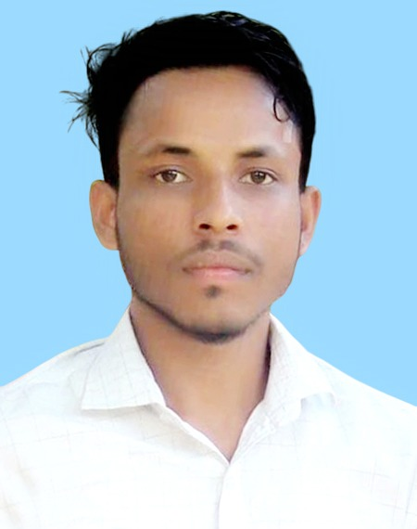
1 | POSITION |  | Trainer
2 | NAME OF STAFF |  | Md Rubel Miah
3 | DATE OF BIRTH |  | 19 May, 1996
4 | NATIONALITY |  | Bangladeshi
5 | Contact Number & E-mail |  | +881714780050, E-mail: rubel0216@gmail.com
6  7 | EDUCATION:  OTHER TRAINING
  Academic Qualification : 1
   | Secondary School Certificate
  Concentration/Major/Group : | Information Technology
  Institute Name : | Dinnath Institution Satkapan Model High School, Bahubal, Habiganj
  Result : | First Class
  Year of Passing : | 2015
  Training : 1
  Training Title : | Advanced Internet Maketing-III
  Topics Covered : | Digital Marketing
  Institute : | cronyco network learning center
  Country : | Bangladesh
  Location : | Habigonj
  Training Year : | 2017
  Duration : | 3 Months
  Training : 2
  Training Title : | SEO training
  Institute : | NEO-training center
  Country : | Bangladesh
  Location : | Habigonj
  Training Year : | 2017
  Duration : | 6 Months
 | LANGUAGES & DEGREE OF  PROFICIENCY |  | Language | Speaking | Reading | Writing
8 |  |  | English  Bangla  Hindi | Excellent  Excellent  Good | Excellent  Excellent  Good | Excellent  Excellent  Good
9 | COUNTRIES OF WORK EXPERIENCE | Bangladesh
10 | EMPLOYMENT RECORD | Sk Network  Position: marketing manager,  Duration: January 2017 to till now  Company Location: Bahubol, Habiganj, Sylhet, Bangladesh  Department: General Manager (ISP)
11 | WORK UNDERTAKEN THAT BEST ILLUSTRATES YOUR CAPABILITY TO HANDLE THIS ASSIGNMENT | - Involvement in App Monetization & App Management Training , ICT Division, July 3 September 30  - Involvement in Training Management at Learning & Earning Development Project, ICT Division, June'2020-  Personal Details :  Name: Md Rubel Miah  Father’s Name: Ahad Ali  Mother’s Name: MST: Jahera Begum  Present Address: Gul Gaw.08 Dubai Bazar, Bahubol, Habiganj, Sylhet, Bangladesh  Permanent Address: Gul Gaw.08 Dubai Bazar, Bahubol, Habiganj, Sylhet, Bangladesh  Marital Status: Unmarried  Sex: Male  Blood Group: A+  Religion: Islam  Emergency contact (Two persons with Relation):  1. Father ( +8801748-003922 )  2. Brother (+88 01711329408 )  Completed Project Work: emoneykicks .com

I, the undersigned, certify that (i) I was not a former employee of the Client immediately before the submission of this proposal, and (ii) to the best of my knowledge and belief, this bio-data correctly describes myself, my qualifications, and my experience. I understand that any wilful misstatement described herein may lead to my disqualification or dismissal, if engaged.

continuously for the Projectare as regular full time staff. Indicate “Yes” or “No” in the boxes below:

 |  |  | YES | √ |  |  | NO

Signature | Md Rubel Miah
Date of Signing | 01 / 07/ 2020

